**Stage 3 – Slow down and get your hits**

**RULES:** USPSA Competition Rules, Latest Edition **COURSE DESIGNER:** Ike Starnes (with some inspiration from Joe Farewell)

|  |  |
| --- | --- |
| **START POSITION: See written stage briefing.** | |
| **STAGE PROCEDURE**  See written stage briefing. | **SCORING**  **SCORING:** Comstock 31 rounds.  **TARGETS:** 13 cardboard targets and 5 steel targets  **SCORED HITS:** 2 best hits per carboard will be scored, steel must fall to score  **START-STOP:**  Audible - Last shot  **PENALTIES:** Per USPSA Competition Rules |

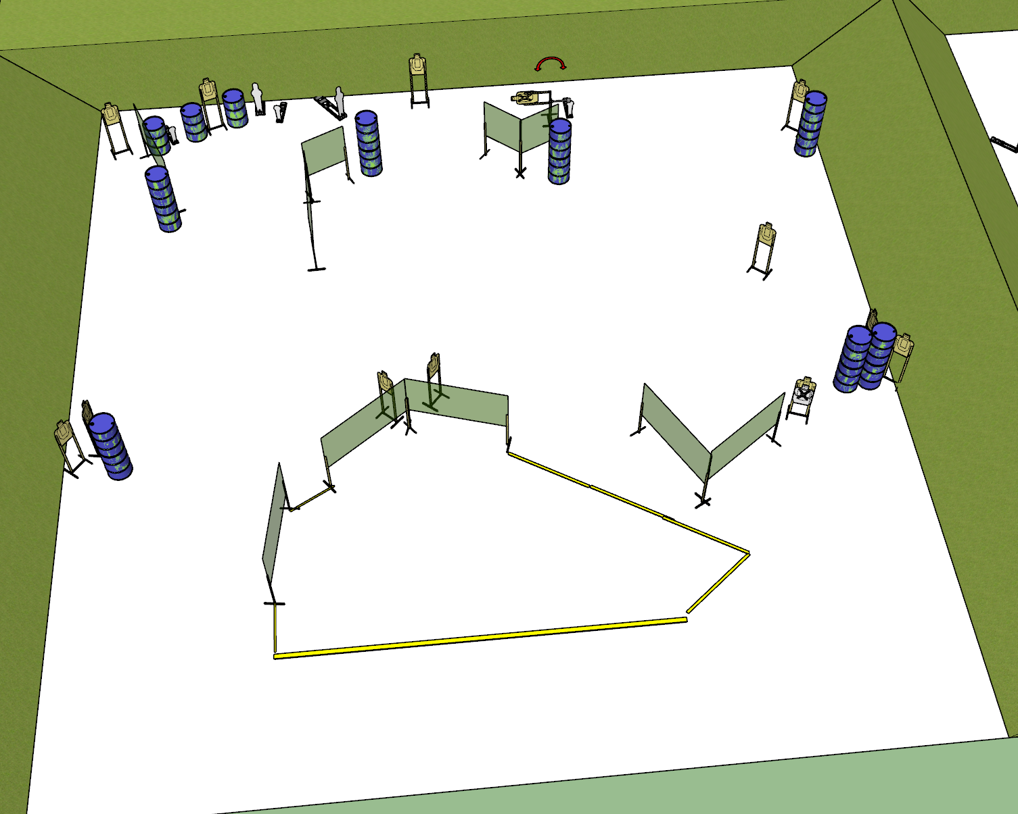

**Written Stage Briefing:**

**Stage 3 – Slow down and get your hits –** is a 31-round, 155 point, Comstock Long Course. There are 13 cardboard targets and 5 steel targets. The best 2 hits per cardboard target will be scored, steel must fall to score.

**Start position** Heels of both feet on the rear fault line.

Handgun: Loaded and holstered with wrists below belt.

PCC: Loaded, stock on belt.

On the audible start signal, engage targets from within the shooting area.

**Setup Notes:**

12 Single Wall Stands

4 Double Wall Stands

7 Full Walls

3 Half Walls

12 Target stands / 24 target sticks

1 swinger

1 activator plate

2 Mini Poppers, 2 bases

2 Poppers, 2 bases

17+ barrels